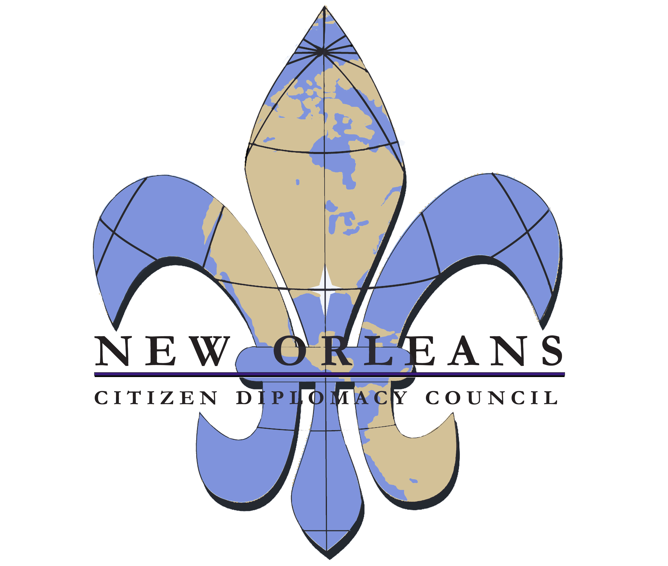
2020 Membership
Support Citizen Diplomacy!

Membership Benefits (All levels)

- Invitations to Members-Only receptions and cultural events;
- Opportunities to meet and host our international visitors for dinner;
- Updates about international events hosted by NOCDC partners;
- Discounted admission to select events of NOCDC partners;
- Discounts at partner Hotels including InterContinental New Orleans, Loews, and Sheraton;
- Subscription to the NOCDC newsletter

Individual Membership
Student $20
Young Member (Under 30) $30
Attaché $45

Memberships for Two
Each level provides additional benefits

Counselor (Two members or “plus one”) $75
- listing in NOCDC event literature

Minister $125
- assistance to connect with
International Visitor Leadership Program
alumni when you travel abroad

Ambassador $250
- includes listing on website

Join/renew on-line at http://www.nocdc.org/membership or mail payment to NOCDC

Member Name:
Address:
Email Address: | Phone Number:
Additional Member Name:
Email Address: | Phone Number:
Member Level: | Payment Amount:
Payment Method: ⬜Check Enclosed ⬜ Payment Made Online

